FCE
(www.fce.dz)
LA FCE è la più importante e più grande organizzazione di imprese in Algeria, paragonata alla nostra Confindustria.
Lo scopo della FCE è di contribuire alla creazione dell'imprenditorialità nell'economia nazionale, di supportare le imprese algerine e di promuovere gli interessi della società algerina al fine di affermare il loro punto di vista e far sentire la propria voce sulla scena economica nazionale, attraverso un dialogo permanente con le autorità economiche, politiche e con tutti gli altri attori economici e sociali (media, sindacati, ricercatori, ecc.). .)

Presieduto dal sig. Ali HADDAD, un imprenditore di spicco di successo, la FCE riunisce oggi circa 3.000 aziende e le sue aziende membri raggiungono un fatturato complessivo di oltre 30 miliardi di dollari

The Forum of Entrepreneurs, President ALI HADDAD con il Presidente Macron (Algeria)
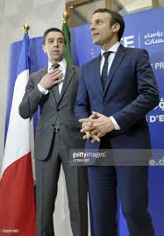
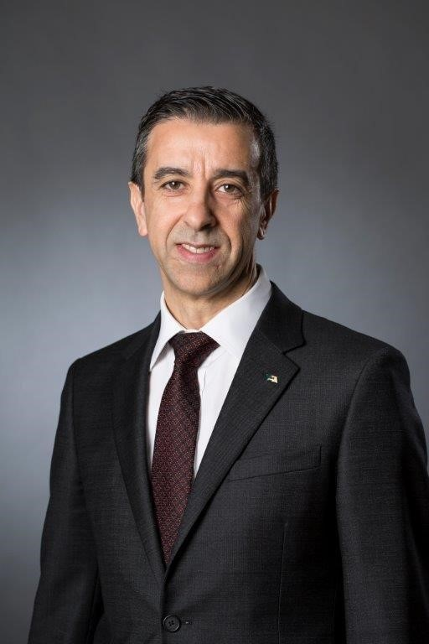

ALI HADDAD
The Forum of Entrepreneurs, President and ETRHB CEO, (Algeria)

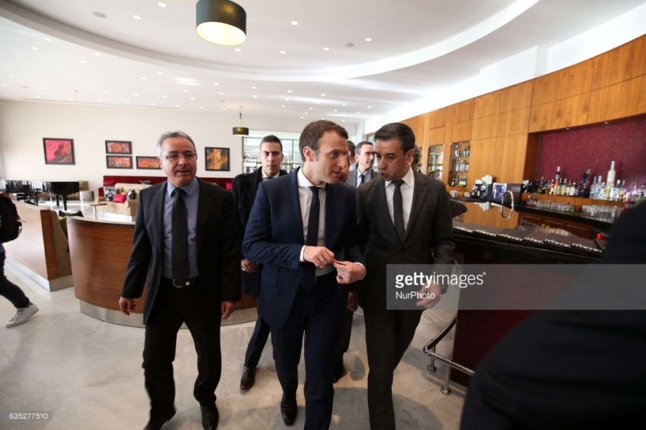
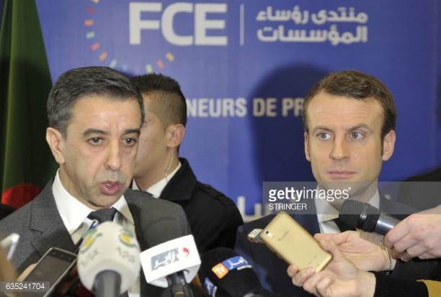

BIOGRAPHY
Ali Haddad, 50 years old was born in Azeffoun, a coasted Town in Algeria. He h olds a degree in civil engineering and a master degree in Business (MBA /EHEDEC – Lille). Right after university in 1987, he started entrepreneurship business with his brothers, realizing “Le Marin” hotel in his hometown.
In 1988, he created and directed the family business of public works, ETRHB marking the beginning of a great adventure in the field of construction.
Throughout the achievement of several regional projects, the company has become a key partner in the realization of major basic infrastructures, for both Algerian authorities and big international groups interested in the Algerian market of construction which became attractive thanks to the several development plans launched since the 2000s.
The involvement of ETRHB Haddad Group in a large number of basic infrastructure projects in the fields of Public Works, Hydraulics and Transport, has led Ali Haddad to earn several national and international awards, including Best Manager Award 2003.
ETRHB Haddad Group’s field of interest was no longer limited to Public work logistic and support activities. In fact, the group led by Ali Haddad extended its interest to the world of media, launching in 2009 a press group, which publishes the following daily newspapers: “Le Temps d’Algérie” in French and “Wakt El Djazair” in Arabic. In 2013 and 2014, the Press Group was expanded including new media: TV channels “Dzair tv” and “Dzair News”.
Since 2013, ETRHB Haddad Group was connected to the medical sector by creating CIALFARM; a company specialized in materials, equipment and medical supplies. Besides, a Memorandum of Understanding was signed in the US in November 2014 between CIALFARM and Varian Medical Systems (VMS), the world leader in radiotherapy equipment to create a joint venture; Varian Medical Systems SPA Algeria.
The ETRHB Haddad Group also invested in Algerian football, becoming in 2010 the owner of the prestigious USM Alger football club. The ETRHB Haddad Group employs nearly 15,000 people with a turnover of 1 Billion US $.
Member of the Algerian Forum of Business Leaders (FCE) since its creation, Ali Haddad won quickly the trust of his peers and ensured several responsibilities within the executive of the organization. This tremendous trust, took him unanimously at presidency of the organization, in November 2014, in favour of an ambitious program that raises the company/Firms at the heart of national development policies.

